

Springfield @

West End



Please can we remind all Parents and Carers, that when collecting/dropping off children, masks must be worn and social distancing measures adhered to. Without the wearing of a face mask, we are unable to accept the child. If your child is unable to walk then please use the provided cots

We have recently welcomed back Emma Thomson to Springfield, after her Maternity Leave. Emma will now be joining our Abergele Nursery as a Senior Manager. West End however, will remain in the very capable hands of Sophie Hughes who is now the permanent Manager alongside Deputy Manager Charlotte Naylor

Due to the closure of our West End Nursery before Christmas we had to sadly cancel our Christmas Party. However we have now rescheduled and will be having a party day on Thursday the 28th January 2021. If you would like to book your child in for this day then please call the nursery on 01492 530626.

We will be rolling out ‘Tapestry’ over the next month or so. This is an easy to use and secure online learning journal which will be used to replace the yellow diaries. On Tapestry we will be able to share pictures of your child during their nursery day, along with activities and progression updates. We will also be able to develop further parent communications using the features within the journal. We hope Tapestry will help staff and families celebrate their children’s learning and development in a safe, secure and instant journal  
  
We will provide further information regarding the roll out of Tapestry over the following weeks.  
  
Have a look at the link below to find out more.

<https://tapestry.info/>

Even though we’ve said goodbye to our summer and warmer weather, the children still love to be outside and we still continue to play outside in the gardens and go for walks. Can all parents please bring some warm clothes for the children, this may include: hats, gloves, waterproofs and wellies to keep the children toasty whilst out enjoying the fresh air. Please remember all belongings should be labelled

We are extremely excited to see the start of our garden renovations this month. The gardens will be transformed into an even greater activity space for all the children to enjoy. We have already started receiving some very exciting packages full of new equipment, so keep an eye on our social media and watch the project unfold to see the progress

Springfield Day Nurseries would like to take this opportunity to thank each and every one of our parents for their support and understanding during these difficult times. Our team have all worked extremely hard over the past year, during these unprecedented times, and it wouldn’t have been possible without the support and cooperation of our nursery parents

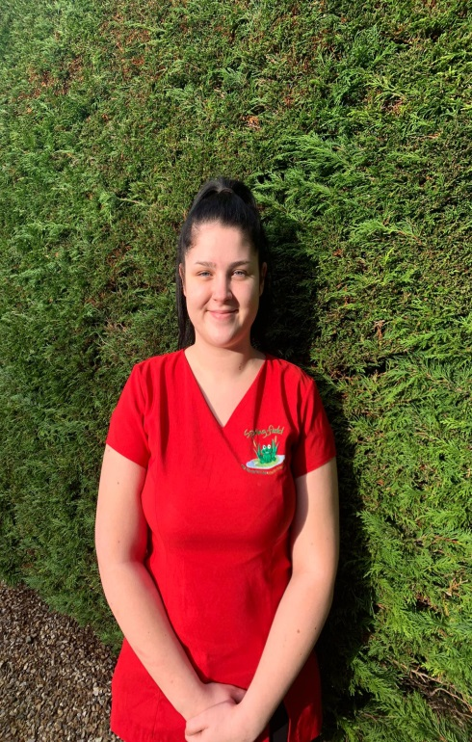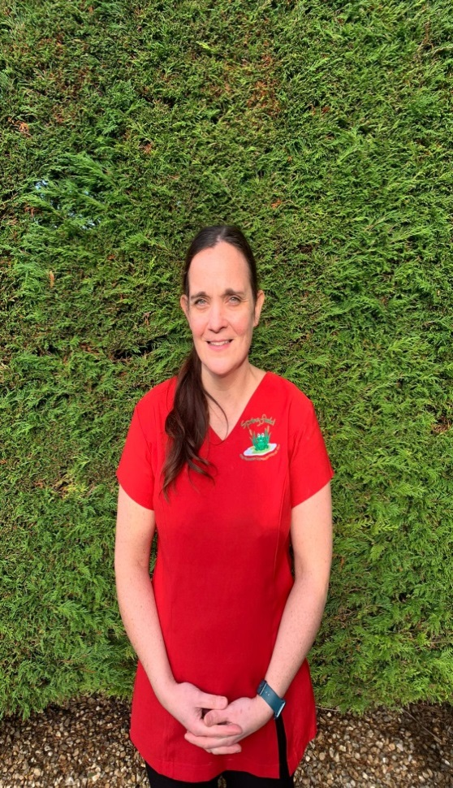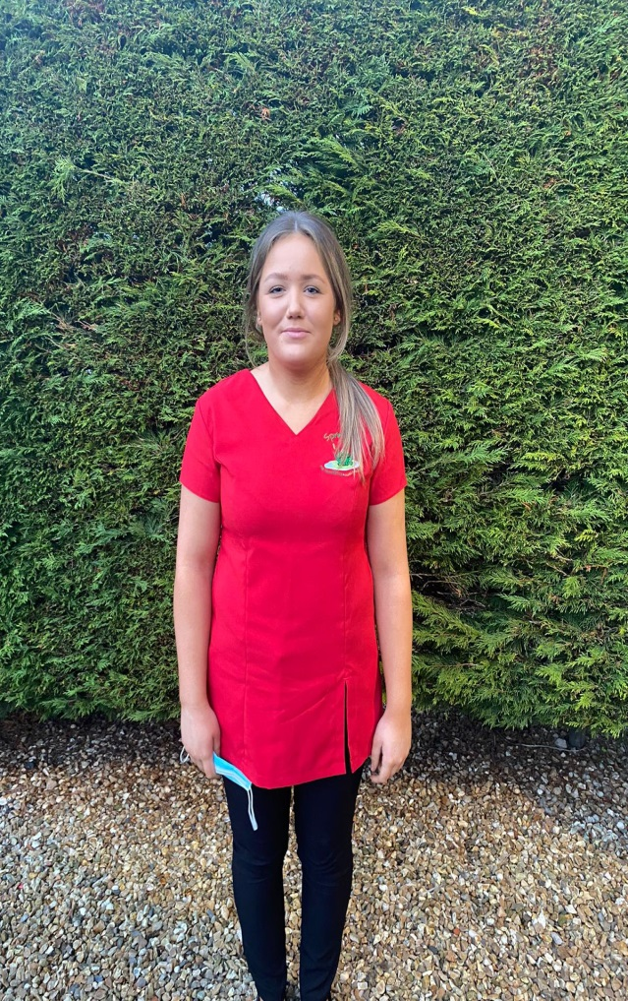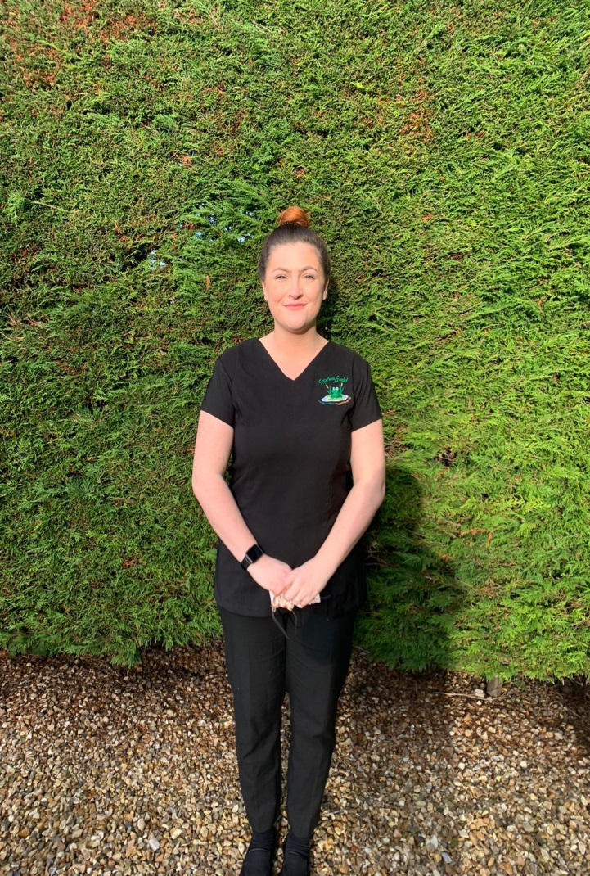

**Eve Hansom**

Nursery Assistant

Baby Room

Hi, I’m Sophie and I’m the manager here at West End.

I’ve worked at Springfield Day Nurseries for a total of 10 years and I now hold a level 5 in Children’s Care, Learning and Development. I started working for the company as a Nursery Assistant in the After School Club at Ashbourne when I was 17 years of age. After two years I left to attend University. In 2013, I returned to the company and worked across all the sites before entering Management four years ago. I have most recently been promoted to permanent Manager of West End Nursery which I am thoroughly enjoying.



**Sarah Ellis**

Nursery Nurse

Baby & Nursery Room

Level 2

**Charlotte Naylor** Assistant Manager

Level 3 CCLD

Undergoing Level 4

**Sarah Jones**

Nursery Supervisor

Level 3 CCLD

Level 3 play work

**Rachel Mercer**

Nursery Nurse

Baby Room

BTEC Childhood Studies Level 3

**Meet the team…**

**Millie Lloyd**

After-school club assistant



**Sam Wharfe**

Pre-School Supervisor

Level 3 CCLD



**Sarah Davies**

Nursery Supervisor

Undergoing Level 3

Springfield @ West End