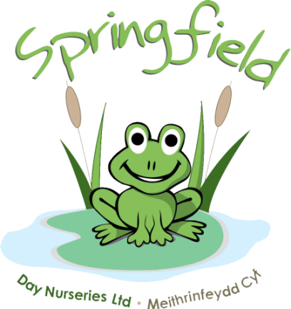

Springfield @ Llandudno

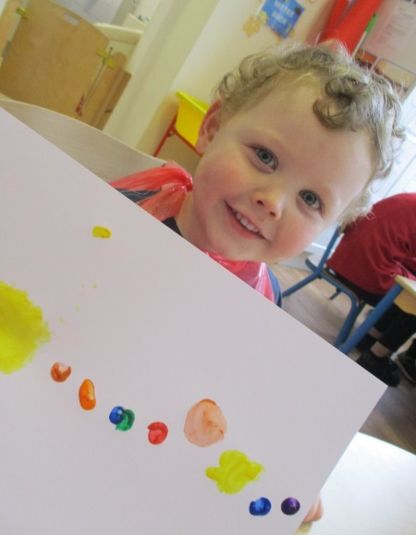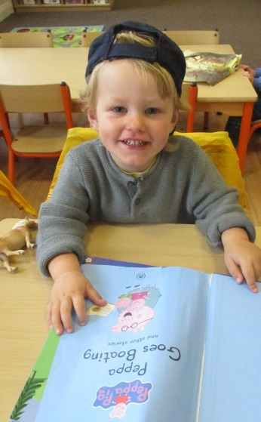

We will be rolling out ‘Tapestry’ over the next month or so. This is an easy to use and secure online learning journal which will be used to replace the yellow diaries. On Tapestry we will be able to share pictures of your child during their nursery day, along with activities and progression updates. We will also be able to develop further parent communications using the features within the journal. We hope Tapestry will help staff and families celebrate their children’s learning and development in a safe, secure and instant journal  
  
We will provide further information regarding the roll out of Tapestry over the following weeks.  
  
Have a look at the link below to find out more.

<https://tapestry.info/>

We are extremely excited to see the start of our garden renovations this month. The gardens will be transformed into an even greater activity space for all the children to enjoy. We have already started receiving some very exciting packages full of new equipment, so keep an eye on our social media and watch the project unfold to see the progress

Springfield Day Nurseries would like to take this opportunity to thank each and every one of our parents for their support and understanding during these difficult times. Our team have all worked extremely hard over the past year, during these unprecedented times, and it wouldn’t have been possible without the support and cooperation of our nursery parents

Please can we remind all Parents and Carers, that when collecting/dropping off children, masks must be worn and social distancing measures adhered to. Without the wearing of a face mask, we are unable to accept the child. If your child is unable to walk then please use the provided cots

Even though we’ve said goodbye to our summer and warmer weather, the children still love to be outside and we still continue to play outside in the gardens and go for walks. Can all parents please bring some warm clothes for the children, this may include: hats, gloves, waterproofs and wellies to keep the children toasty whilst out enjoying the fresh air. Please remember all belongings should be labelled

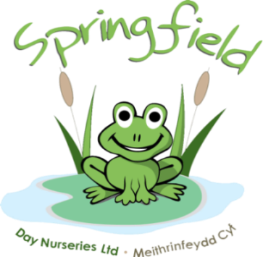

Hi, I’m Emma and I’m the Manager here at Llandudno Nursery.

I’ve worked for Springfield Day Nurseries for 21 years. I started as a Nursery Assistant and worked my way up to Baby Rom Supervisor. I have been in a Manager’s position since 2006.



**Anwen Rogerson**

Assistant Manager

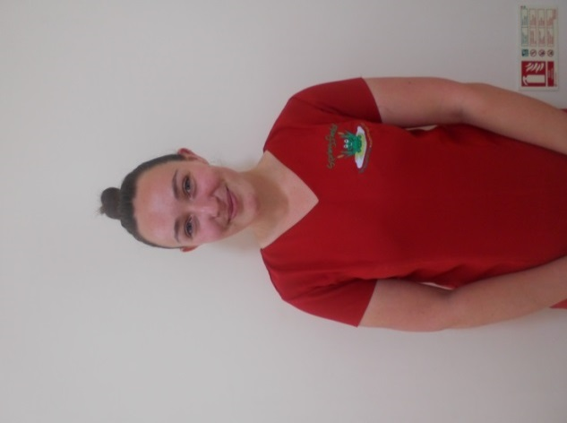

**Lucy Pugh**

Baby Room Supervisor

Level 2

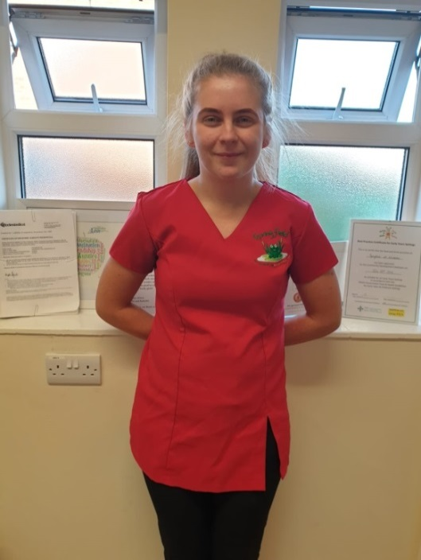

**Millie Johnson**

Baby Room

Nursery Assistant

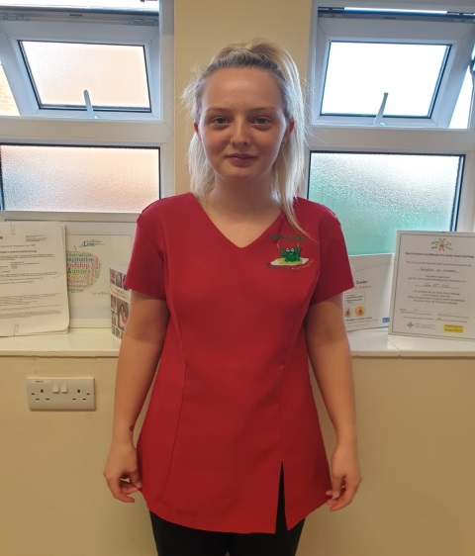

**Ffion Bennet**

Baby Room

Nursery Assistant

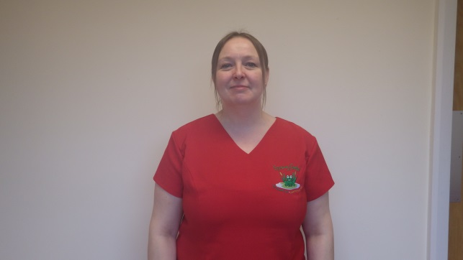

**Jennifer Winterbottom**

Nursery Assistant

Undergoing Level 2



**Vikki Kierlik**

Pre-School Supervisor

Undergoing Level 3

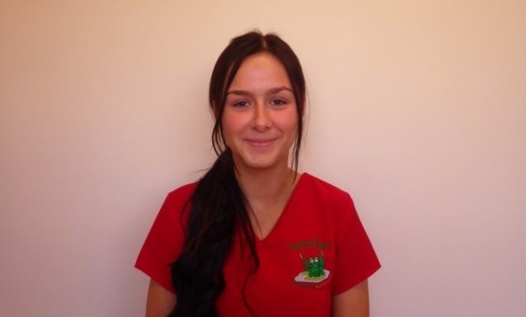

**Emily Watson**

Nursery Room

Level 2

**Jasmine Sartain-Berry**

Nursery & Pre-School

Nursery Assistant

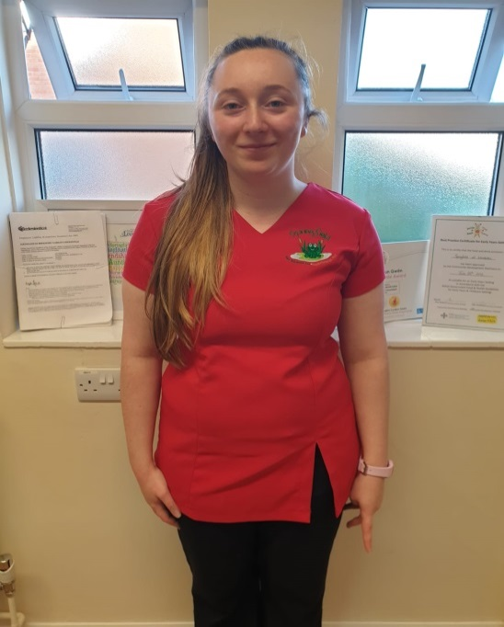

**Lowri Sharpe**

Nursery Supervisor

Level 3

Springfield @ Llandudno

**Meet the team…**