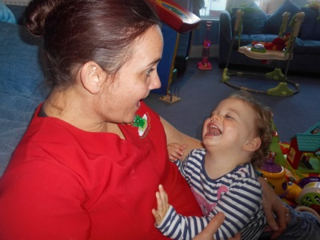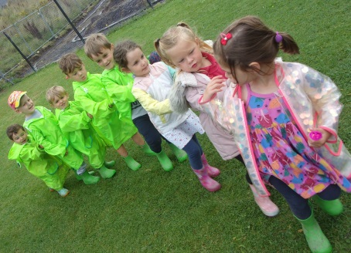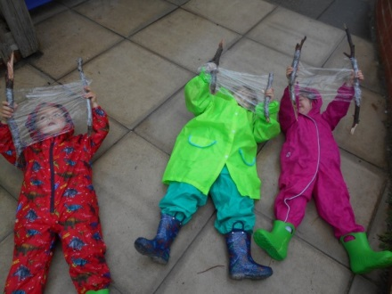

**OUTDOOR ACTIVITIES**

Sarah Wintle is now our Outdoor and Development Coordinator! She plans outdoor activities for all the children to take part in each day. The plans include activities for each area of the garden i.e. Sand pit, mud kitchen and water area. They are all based on a story

In the New Year, we will be starting the long-awaited renovations which have been delayed due to Covid-19.These will see the gardens transformed into an even greater activity space for all the children to enjoy. We will have new sandpits, mud kitchens, playhouses and even an activity hill and underground tunnels!

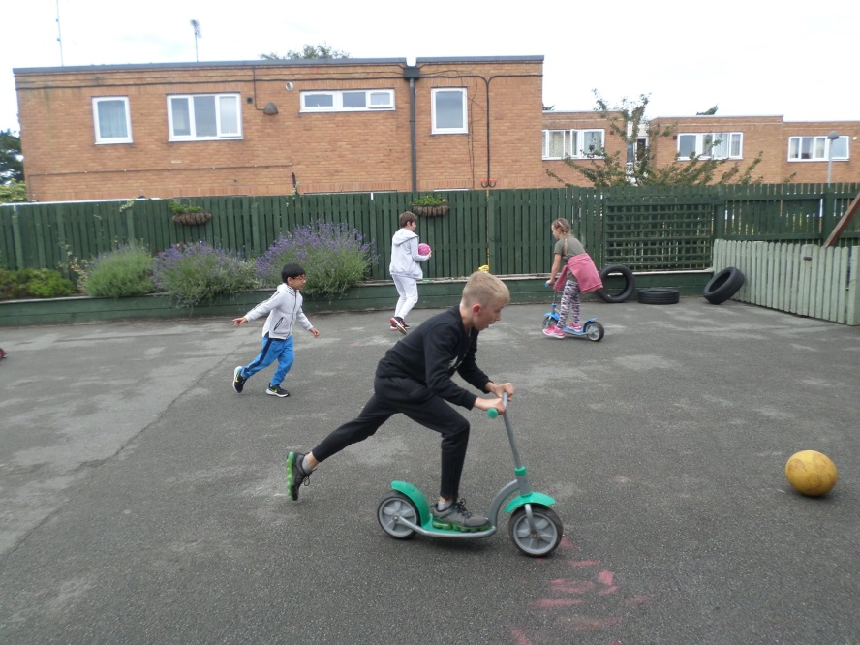

**DIRECT DEBIT DATES**

Please be aware due to Christmas & bank holidays we will be taking Direct Debits as follows:

**Friday 18th December**

(normal)

**Tuesday 29th December**

(instead of 25th December)

**Monday 4th January**

(instead of 1st January)

**Friday 8th January**

(Normal)

**OPENING TIMES**

All nurseries will be closing at 3pm on Christmas Eve and New Year’s Eve.

The nurseries will also be closed on the bank holidays, but open as normal all other days.

**FEEDBACK**

This year we collated all of the feedback from our Parent Feedback Forms and we are using these to implement changes to our nurseries.

You said you would like us to be more digital, and so hopefully by Christmas, we will have a system which you will be able to log into and see how your child’s day has been. You will see what they’ve had to eat, if they’ve slept and what fun activities they’ve taken part in that day, along with photographs!

We have also improved our outdoor play and spend lots more time in the garden and this will be enhanced even more by our planned renovations.

**DATES FOR THE DIARY**

Christmas Jumper Day –

Friday 11th December

Tuesday 15th December –

Christmas lunch Conwy & Llandudno

Thursday 17th December –

Christmas lunch Ashbourne, Abergele & West End

Wednesday 23rd December –

Party in each nursery

Thursday 24th December –

Clap for Christmas Eve

January – Progress Reports

**DRAGON CAMPS**

We run holiday camps, in the County of Conwy, North Wales, delivering a jam-packed programme to keep children aged 4 to 14 happy during the school holidays.

All camps this Christmas (21st – 31st Dec) will be held at Ashbourne nursery and we recommend booking your child’s place early to avoid disappointment.

Book by Wednesday 16th December to take advantage of our Early Bird price

On the **24th and 31st December** there will be a Dragon Camp party which includes games and party food. Full details online at www.dragoncamps.com

**DIRECT DEBITS**



**NEWS**

**We would like to start by thanking all Parents and Staff for their continued support this year.**

We’ve all been through a tough time but we feel we have worked together as a team and continued to provide our excellent service. We missed all the children when we were unable to fully open and we were so pleased when all their smiling faces returned.

Unfortunately Christmas this year will be slightly different as we will be unable to hold our usual Christmas Carol service at St Pauls Church due to COVID-19 restrictions.

**However** we will still be having our fantastic Christmas parties, within our bubbles on the 23rd December at all five nurseries. The children can wear their best party outfits or even fancy dress if they wish.

NEWSLETTER - **December 2020**





**HALLOWEEN**

All the children had great fun celebrating Halloween this year. Everyone looked fabulous in their costumes and really made a great effort. They decorated their nursery, had party food and made some spooky crafts

**Introducing…**

David & Suzanne Edwards.

David and Suzanne have owned Springfield Day Nurseries for over 15 years and have grown the business from one nursery in Colwyn Bay to five across North Wales.

Suzanne is a former nurse with an NNEB, who dreamed of opening her own Nursery and providing excellent childcare to the children in her local area. David is from a financial and marketing background and therefore together they made the perfect team to open and run Springfield Day Nurseries Ltd.

Now, they provide childcare to over 400 children and employ approximately 80 staff. Even as the business has grown, their love and dedication is still just as apparent as when they started, and that’s why you’ll catch Suzanne welcoming parents and children to our nurseries every morning and David driving the big froggy bus back and forth to school everyday. David and Suzanne are also continually looking  for ways to develop their service and ensure a fantastic  early years education for every child that joins so keep your eye out for all their exciting plans for this year.

**CHRISTMAS LUNCH**

Christmas Lunch will be served for all children and staff on the:

**15th December for Conwy and Llandudno**

**17th for Ashbourne, West End and Abergele**

The menu for this day shall be:

**Breakfast:** Variety of cereals available

**Lunch:** Roast turkey with creamed mashed potatoes and roast potatoes, stuffing balls, pigs in blankets with sprouts, carrots and swede topped with cranberry rich stocked gravy.

**Vegetarian Option available**

**Dessert:** Chocolate Orange slice with a drizzle of fresh cream

**Afternoon Tea:** Muffins with a variety of preserves and a Christmas frosted cupcake and fresh fruit slices

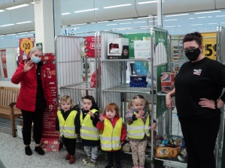

Well done to all Parents, Aunties & Children for raising money and collecting food for the local food banks for Children in Need. Some children then went to our local Morrison’s to donate the food.

Childcare Offer & Flying Start applications are now open for January!

Well done to all Parents, Aunties & Children for raising money and collecting food for the local food banks for Children in Need. Some children then went to our local Morrison’s to donate the food.