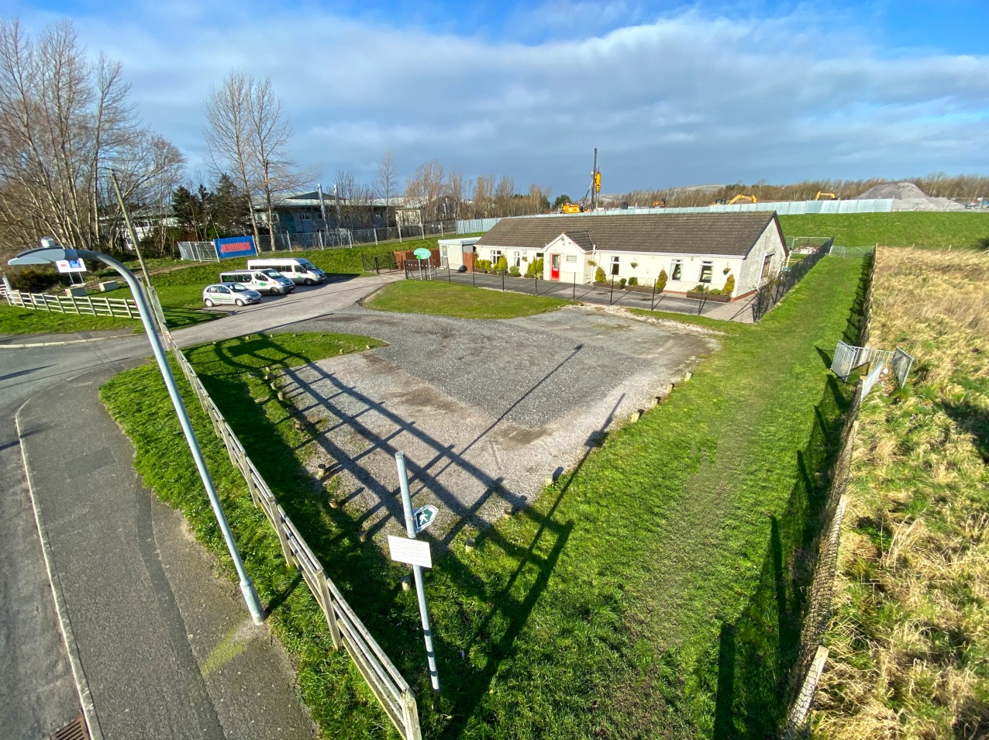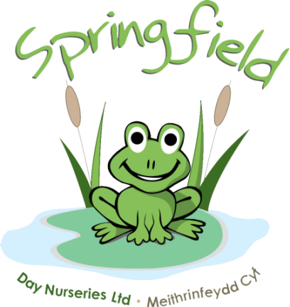

Springfield @

Conwy

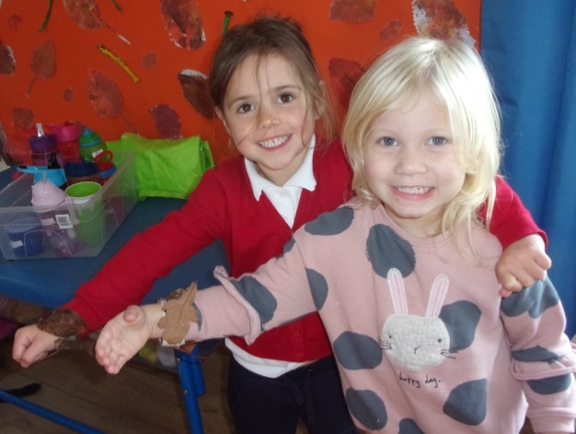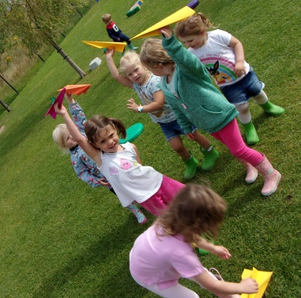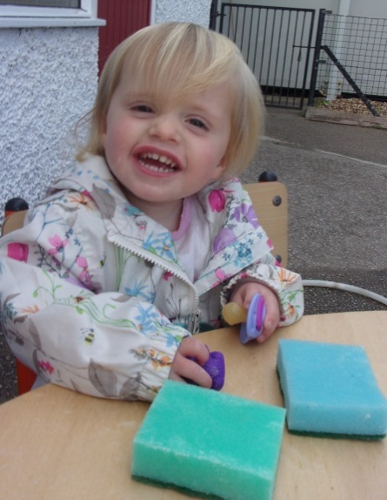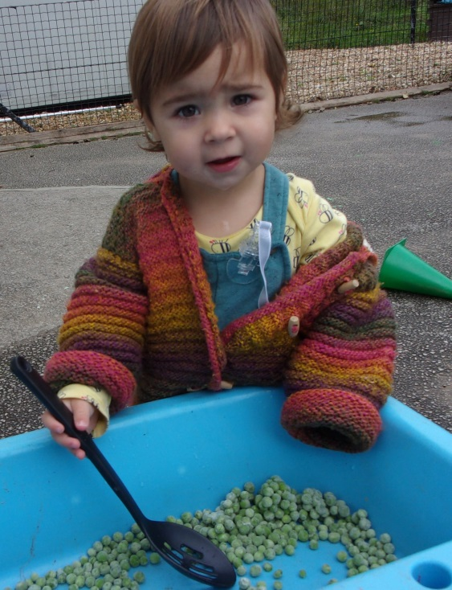

Alex Rimmington, Assistant Manager has now left to start her maternity leave. Alex is expecting her second boy and we wish her all the luck. Hannah Powell from Abergele nursery is currently covering Alex’s maternity leave and it’s great to have her here

Please can we remind all Parents and Carers, that when collecting/dropping off masks must be worn and social distancing measures adhered to. Without the wearing of a face mask, we are unable to accept the child. If your child is unable to walk then please use the provided cots

Springfield Day Nurseries would like to take this opportunity to thank each and every one of our parents for their support and understanding during these difficult times. Our team have all worked extremely hard over the past year, during these unprecedented times, and it wouldn’t have been possible without the support and cooperation of our nursery parents

We are extremely excited to see the start of our garden renovations this month. The gardens will be transformed into an even greater activity space for all the children to enjoy. We have already started receiving some very exciting packages full of new equipment, so keep an eye on our social media and watch the project unfold to see the progress

We will be rolling out ‘Tapestry’ over the next month or so. This is an easy to use and secure online learning journal which will be used to replace the yellow diaries. On Tapestry we will be able to share pictures of your child during their nursery day, along with activities and progression updates. We will also be able to develop further parent communications using the features within the journal. We hope Tapestry will help staff and families celebrate their children’s learning and development in a safe, secure and instant journal  
  
We will provide further information regarding the roll out of Tapestry over the following weeks.  
  
Have a look at the link below to find out more.

<https://tapestry.info/>

Even though we’ve said goodbye to our summer and warmer weather, the children still love to be outside and we still continue to play outside in the gardens and go for walks. Can all parents please bring some warm clothes for the children, this may include: hats, gloves, waterproofs and wellies to keep the children toasty whilst out enjoying the fresh air. Please remember all belongings should be labelled

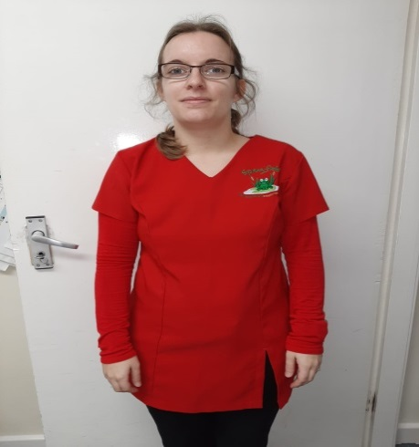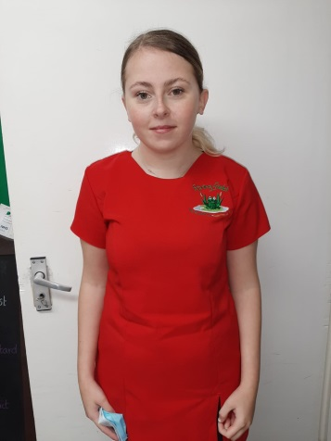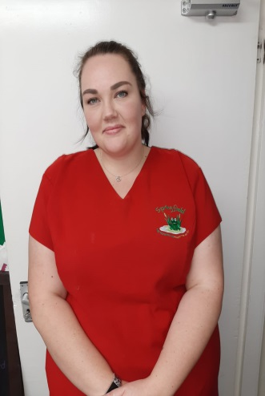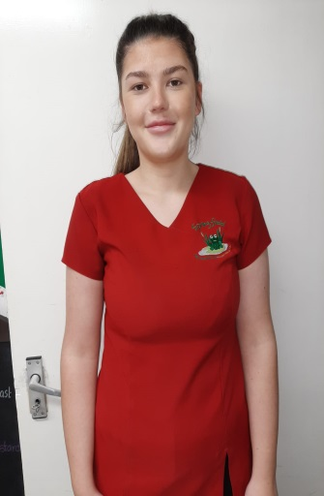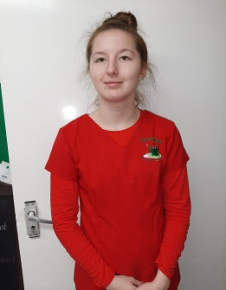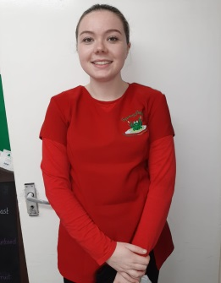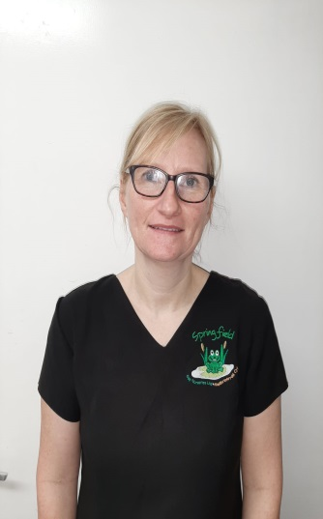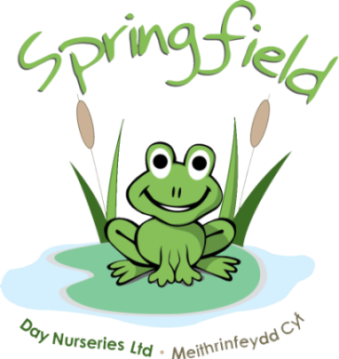

**Alex Rimmington**

NVQ Level3

Assistant Manager

**Rachelle Walker**

Undergoing Level 3

Nursery Supervisor

BA Honours in Primary Education

**Yasmin Winders**

Nursery Nurse

Pre-School

**Lindsay Davies**

Nursery Assistant

Nursery Room

**Molly Kewely**

Nursery Assistant

Nursery Room

**Seren Davies**

Nursery Assistant

Afterschool Club

**Faye Duffy**

Nursery Assistant

Undergoing Level 2

Nursery Room

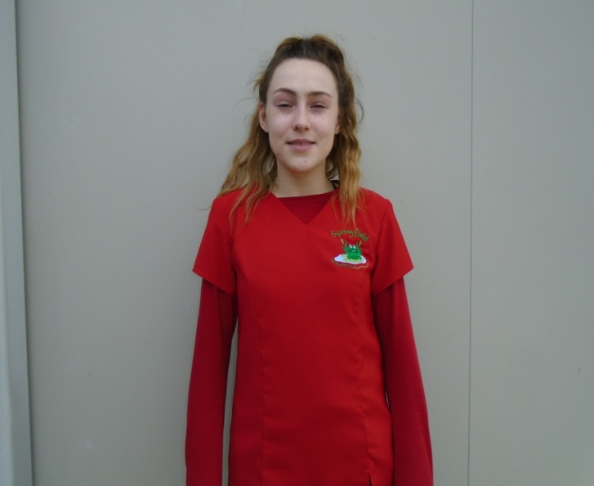

**Sam Oldrey**

Undergoing Level 2

Maternity Leave

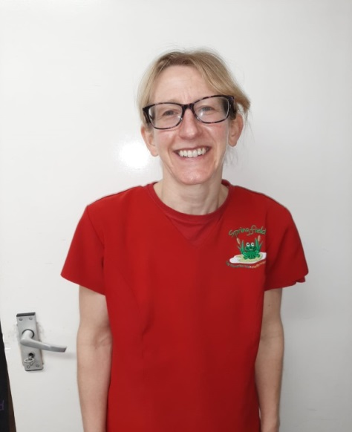

**Janet Bailey**

Pre-School Supervisor

Level 3

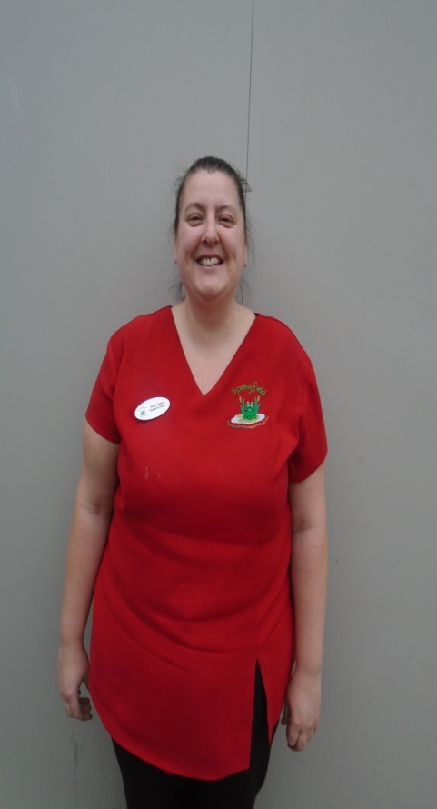

**Emma Jones**

NVQ Level3

Baby Room Supervisor

Baby Room

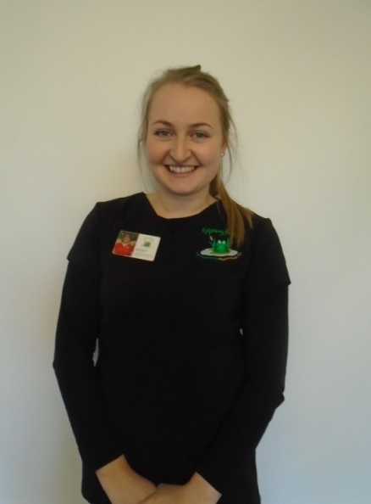

**Hannah Powell**

NVQ Level3

Manager



**Becky Hopwood**

Undergoing Level 2

Nursery Assistant

Baby Room

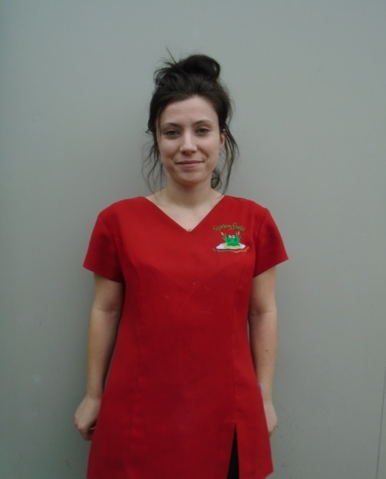

**Lydia Hughes**

Undergoing Level 3

Nursery Nurse

Baby Room



**Emily Hurst**

Nursery Room Supervisor

Maternity Leave

Hi I’m Karen and I’m the manager here at Conwy.

I have been working for Springfield Day Nurseries since April 2004. I worked in Ashbourne and then was promoted to Baby Unit Supervisor and then Deputy Manager of the nursery. I then moved to Conwy in 2011 to be the Manager.

**Meet the team…**

Springfield @ Conwy