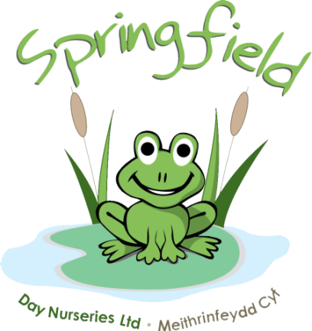

Springfield @

Ashbourne

House

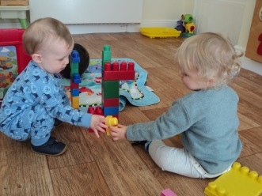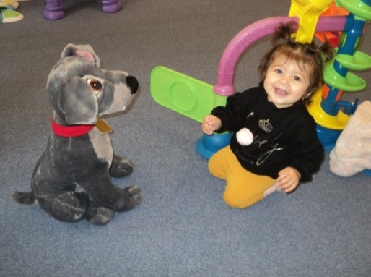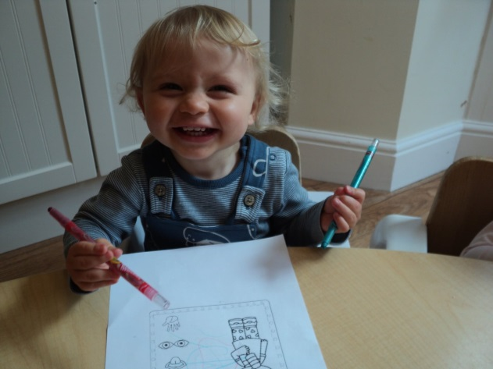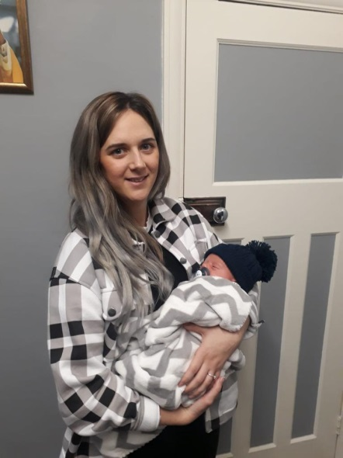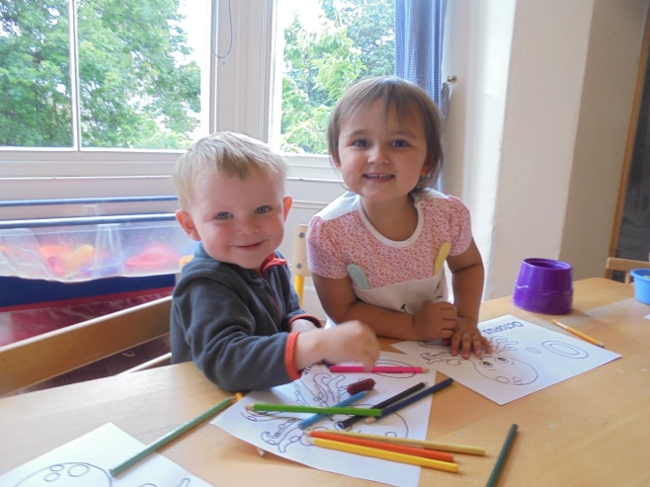

Congratulations to Becky and her partner Callum on the arrival of baby Roman

Even though we’ve said goodbye to our summer and warmer weather, the children still love to be outside and we still continue to play in the gardens and go for walks.

Can all parents please bring some warm clothes for their child. This may include: hats, gloves, waterproofs and wellies. These will keep the children toasty whilst out enjoying the fresh air. Please remember all belongings should be labelled

We will be rolling out ‘Tapestry’ over the next month or so. This is an easy to use and secure online learning journal which will be used to replace the yellow diaries. On Tapestry we will be able to share pictures of your child during their nursery day, along with activities and progression updates. We will also be able to develop further parent communications using the features within the journal. We hope Tapestry will help staff and families celebrate their children’s learning and development in a safe, secure and instant way  
  
We will provide further information regarding the roll out of Tapestry over the following weeks  
  
Have a look at the link below to find out more

<https://tapestry.info/>

Please can we remind all Parents and Carers, that when collecting/dropping off children, masks must be worn and social distancing measures adhered to. Without the wearing of a face mask, we are unable to accept the child. If your child is unable to walk then please use the provided cots

Springfield Day Nurseries would like to take this opportunity to thank each and every one of our parents for their support and understanding during these difficult times. Our team have all worked extremely hard over the past year, during these unprecedented times, and it wouldn’t have been possible without the support and cooperation of our nursery parents

We are extremely excited to see the start of our garden renovations this month. The gardens will be transformed into an even greater activity space for all the children to enjoy. We have already started receiving some very exciting packages full of new equipment, so keep an eye on our social media and watch the project unfold to see the progress

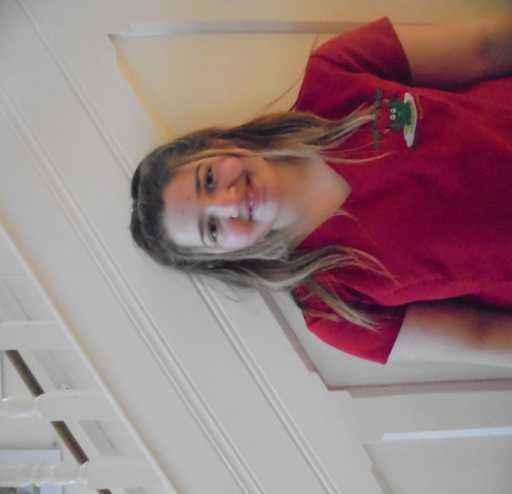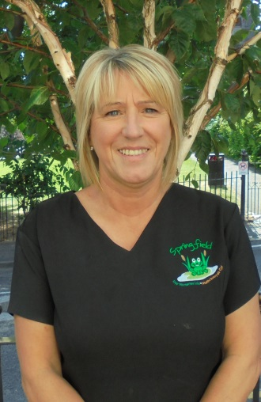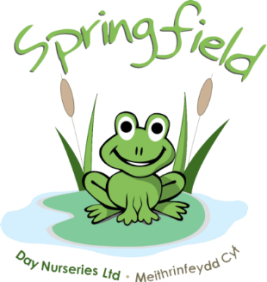

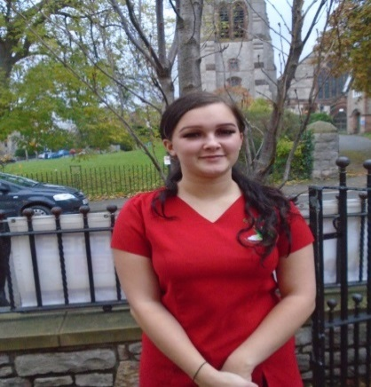

**Abbey Ware**

Nursery Assistant

Baby Unit

Undergoing Level 2

**Abigail Rance**

Afterschool Club

**Jenna Jones**

Nursery Nurse

Afterschool Club

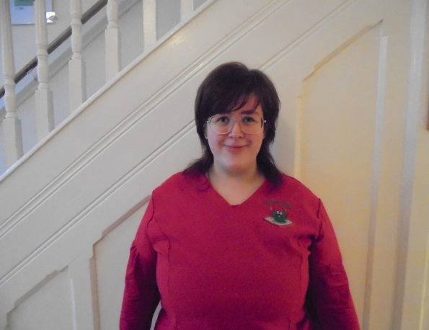

**Bethany Hibbert**

Nursery Nurse

Pre-School

Level 3

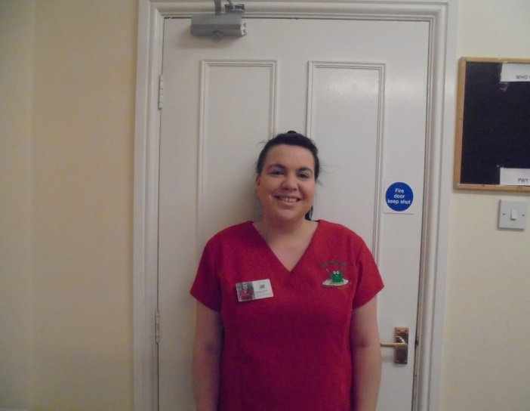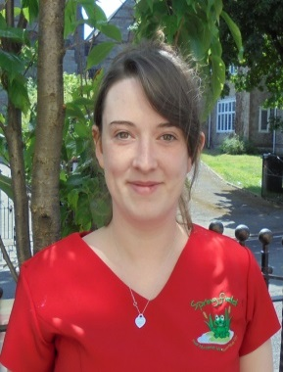

**Alex Armitage**

Nursery Assistant

Toddler Room

Undergoing Level 2

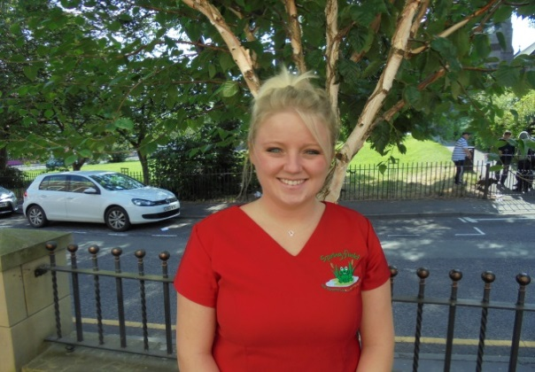

**Jess Bower**

Nursery Nurse

Toddler Room

Undergoing Level 3

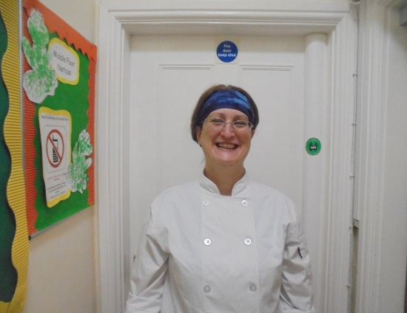

**Elaine Davies**

Food Hygiene

Level 2

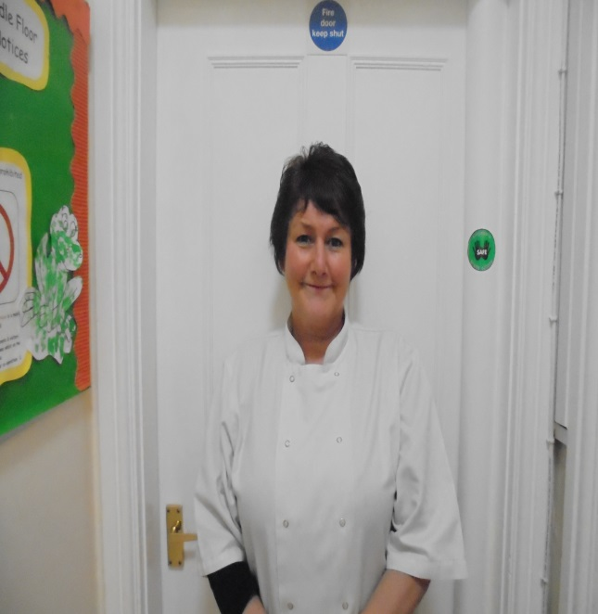

**Linda Hill**

Food Hygiene Level 2

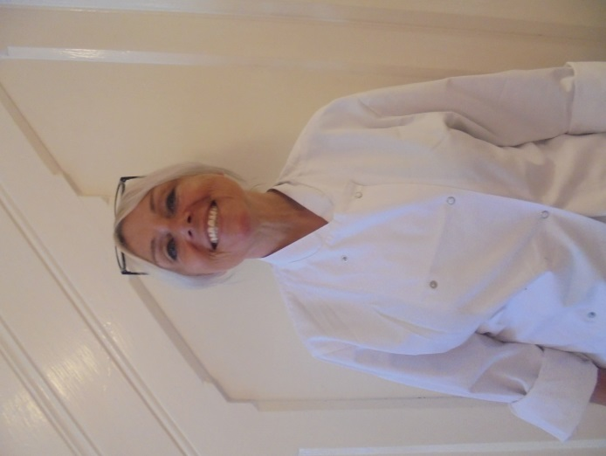

**Adele Turner**

Catering Manager

Catering & Hospitality Level 2

Food Hygiene Level 2

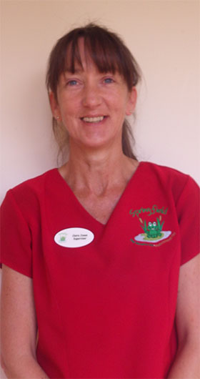

**Claire Jones**

Assistant Manager

(Covering maternity)

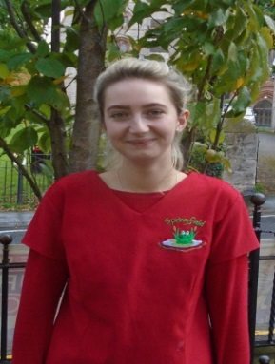

**Emily Jones**

Nursery Supervisor

Level 3

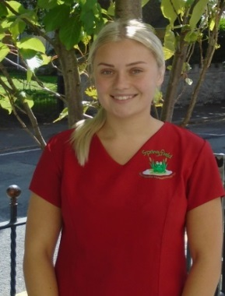

**Natalie Gladwysh**

Assistant Manager

(Covering maternity)

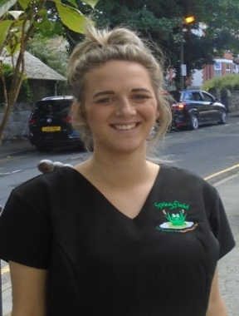

**Becky Maitas**

Assistant Manager

Hi I’m Jackie and I’m the manager here at Ashbourne House.

When I first started at Springfield I was based in Baby Room at our Llandudno nursery and after a few months, I was promoted to Nursey Room Supervisor. After a while I then became Senior Supervisor of Pre-School and Nursery. I worked in Llandudno for around 4 years before moving over to Ashbourne to be Pre-School Supervisor and then Assistant Manager, covering Maternity. I have worked for the company for six and a half years and have completed CCLD level 2 and 3 and have almost completed my CCLD level 5. Most recently I have been promoted to Manager of Ashbourne House.

**Meet the team…**

Springfield @ Ashbourne House