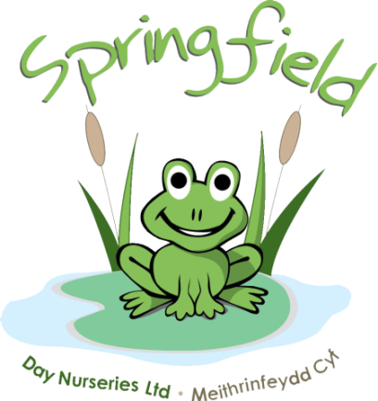

Springfield @

Abergele

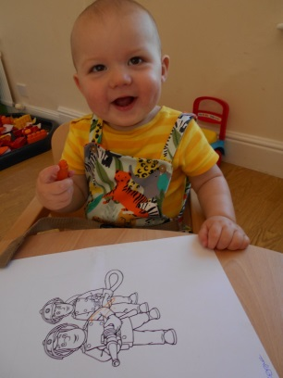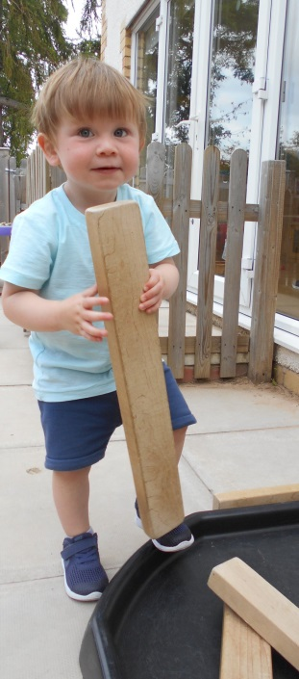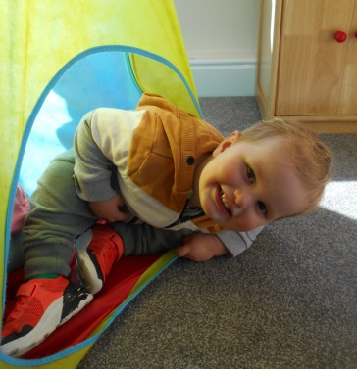

We have recently welcomed back Emma Thomson to Springfield, after her Maternity Leave. Emma will now be joining our Abergele Nursery as a Senior Manager. We have sadly said goodbye to Hannah Powell and would like to wish her luck with her new venture of becoming a nurse

Springfield Day Nurseries would like to take this opportunity to thank each and every one of our parents for their support and understanding during these difficult times. Our team have all worked extremely hard over the past year, during these unprecedented times, and it wouldn’t have been possible without the support and cooperation of our nursery parents

We are extremely excited to see the start of our garden renovations this month. The gardens will be transformed into an even greater activity space for all the children to enjoy. We have already started receiving some very exciting packages full of new equipment, so keep an eye on our social media and watch the project unfold to see the progress

Please can we remind all Parents and Carers, that when collecting/dropping off children, masks must be worn and social distancing measures adhered to. Without the wearing of a face mask, we are unable to accept the child. If your child is unable to walk then please use the provided cots

We will be rolling out ‘Tapestry’ over the next month or so. This is an easy to use and secure online learning journal which will be used to replace the yellow diaries. On Tapestry we will be able to share pictures of your child during their nursery day, along with activities and progression updates. We will also be able to develop further parent communications using the features within the journal. We hope Tapestry will help staff and families celebrate their children’s learning and development in a safe, secure and instant journal  
  
We will provide further information regarding the roll out of Tapestry over the following weeks.  
  
Have a look at the link below to find out more.

<https://tapestry.info/>

Even though we’ve said goodbye to our summer and warmer weather, the children still love to be outside and we still continue to play outside in the gardens and go for walks. Can all parents please bring some warm clothes for the children, this may include: hats, gloves, waterproofs and wellies to keep the children toasty whilst out enjoying the fresh air. Please remember all belongings should be labelled

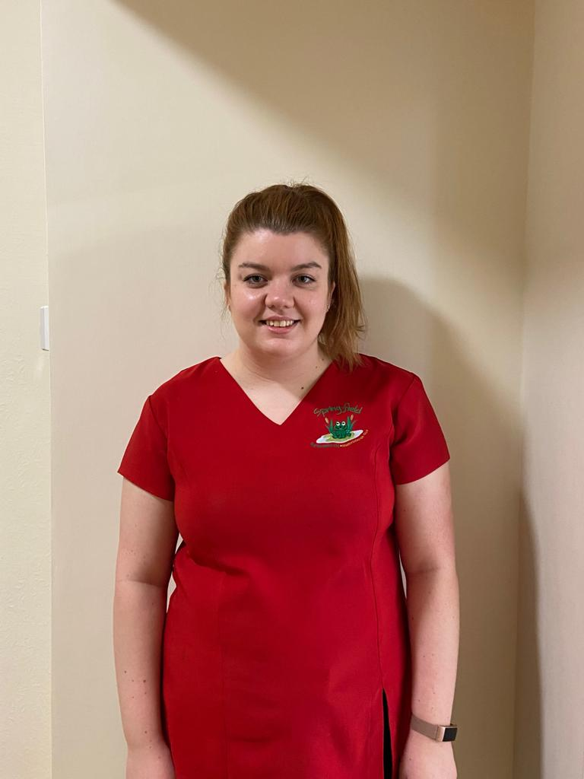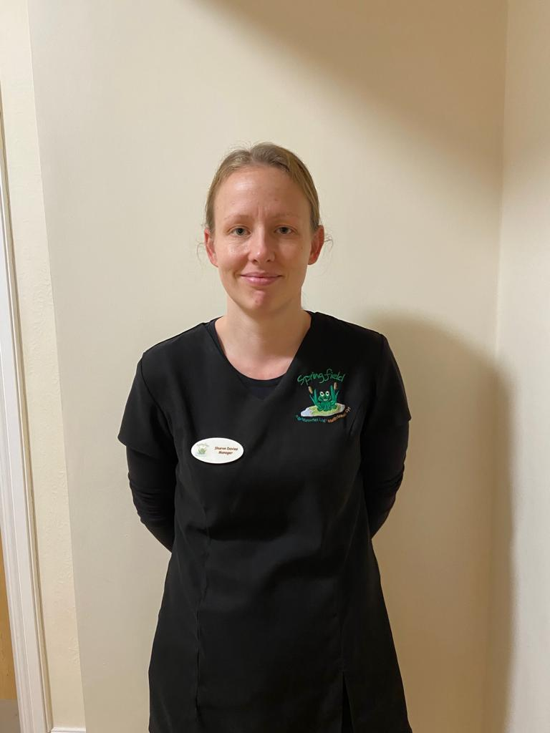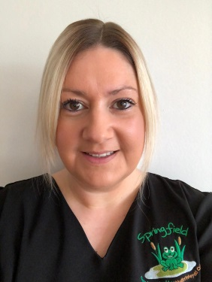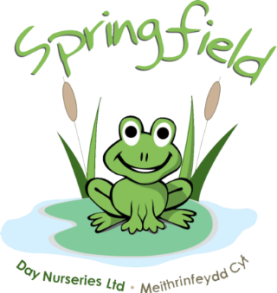

**Bethan Ricketts**

Nursery Assistant

Nursery Room

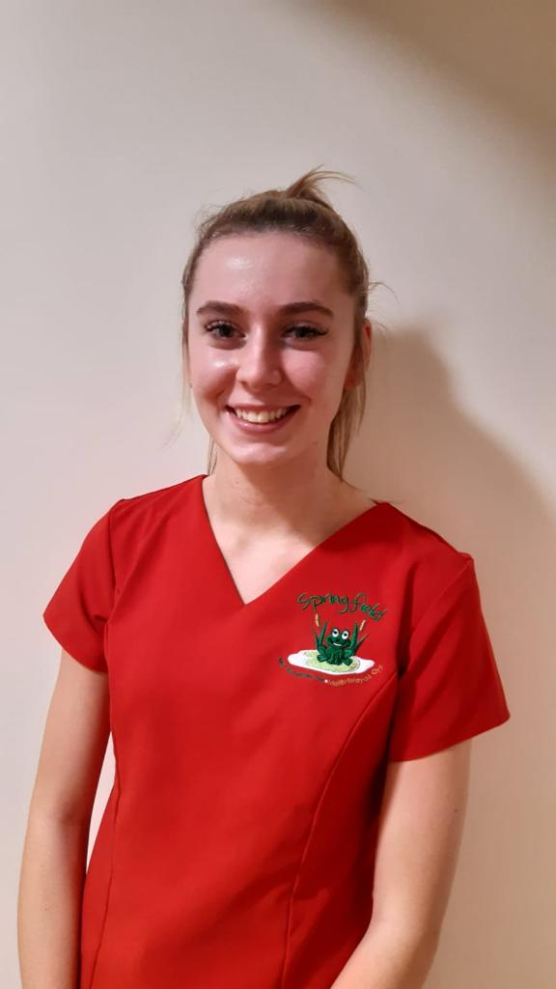

**Sophie Truesdale**

Afterschool Club

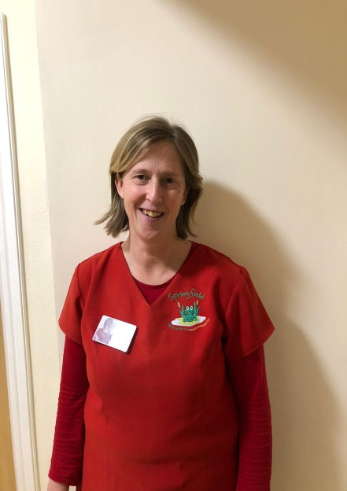

**Sarah Wintle**

Pre-School

Development & Outdoor Coordinator

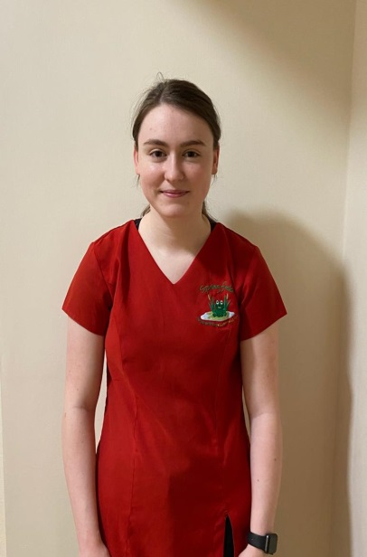

**Kira Peers**

Nursery Assistant

Baby Room

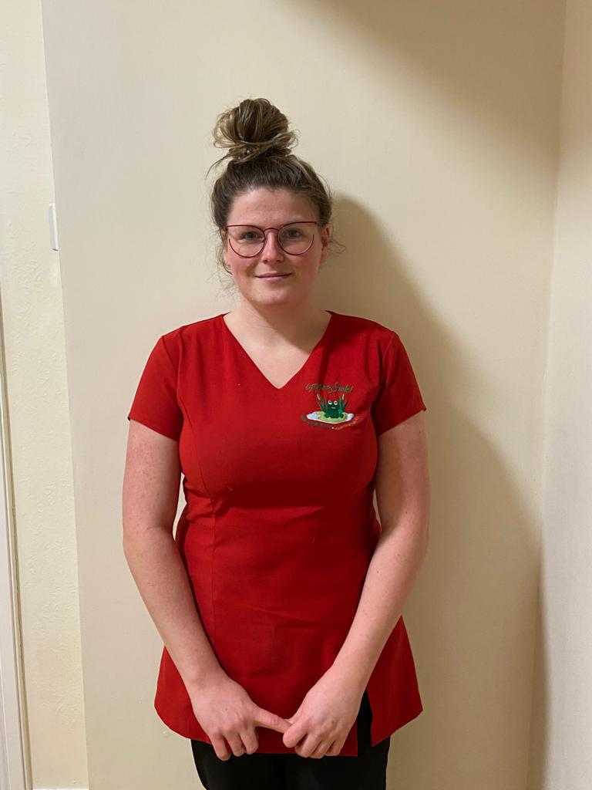

**Emma Powell**

Nursery Assistant

Pre-School &

Afterschool club

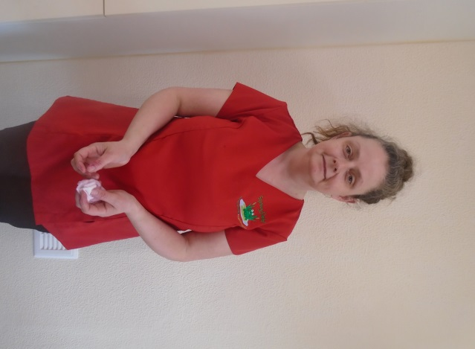

**Suzanne Wilkes**

Baby Room Supervisor

Undergoing Level 3

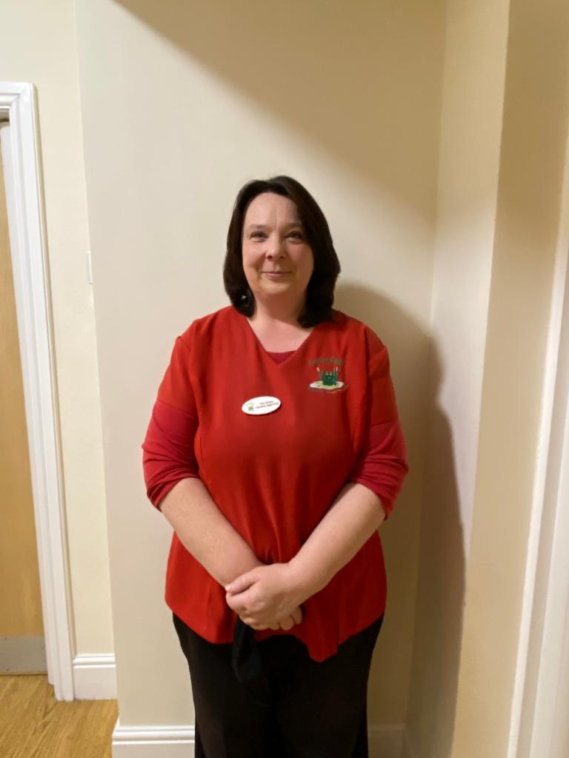

**Zoe Wilson**

Nursery Supervisor

Level 4

Hi, I’m Sharon and I’m the Manager here at Abergele Nursery.

I have worked for the company for 14 years. I started off as a Nursery Nurse in West End and progressed to Baby Room Supervisor and then to Assistant Manager alongside Emma Thomson as my Manager. On the opening of Abergele in 2017, I became the Nursery Manager.

Hi, I’m Emma and I’m the Senior Manager here at Abergele Nursery.

I first joined the company whilst at sixth form and I became the assistant of after school club in Ashbourne House Day Nursery. I have worked for the company for almost 20 years and during this time I have gained my qualifications and worked my way through the company achieving the roles of Supervisor, Assistant Manager and Manager. Since returning from maternity leave this January, I have now been promoted to Senior Manager here at Abergele to work alongside and support Sharon.

**Meet the team…**

Springfield @ Abergele